**Default constraint in sql server - Part 4**

In Part 3 of this video series, we have seen how to create tables (tblPerson and tblGender) and enforce primary and foreign key constraints. [Please watch Part 3, before continuing with this session.](http://csharp-video-tutorials.blogspot.com/2012/08/creating-and-working-with-tables-part-3.html)  
  
  
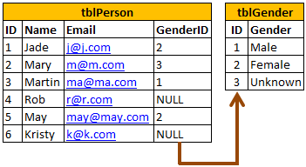  
  
  
  
  
In this video, we will learn adding a Default Constraint. A column default can be specified using Default constraint. The default constraint is used to insert a default value into a column. The default value will be added to all new records, if no other value is specified, including NULL.  
  
  
**Altering an existing column to add a default constraint:**  
ALTER TABLE { TABLE_NAME }  
ADD CONSTRAINT { CONSTRAINT_NAME }  
DEFAULT { DEFAULT_VALUE } FOR { EXISTING_COLUMN_NAME }  
  
  
**Adding a new column, with default value, to an existing table:**  
ALTER TABLE { TABLE_NAME }   
ADD { COLUMN_NAME } { DATA_TYPE } { NULL | NOT NULL }   
CONSTRAINT { CONSTRAINT_NAME } DEFAULT { DEFAULT_VALUE }  
  
  
**The following command will add a default constraint, DF_tblPerson_GenderId.**  
ALTER TABLE tblPerson  
ADD CONSTRAINT DF_tblPerson_GenderId  
DEFAULT 1 FOR GenderId  
  
  
The insert statement below does not provide a value for GenderId column, so the default of 1 will be inserted for this record.  
Insert into tblPerson(ID,Name,Email) values(5,'Sam','s@s.com')  
  
  
On the other hand, the following insert statement will insert NULL, instead of using the default.  
Insert into tblPerson(ID,Name,Email,GenderId) values (6,'Dan','d@d.com',NULL)  
  
  
**To drop a constraint**  
ALTER TABLE { TABLE_NAME }   
DROP CONSTRAINT { CONSTRAINT_NAME }  
  
  
In the next session, we will learn about cascading referential integrity